Observed and sampled catch report - outline

06032023

**Description:**

This is an outline for a revised report on observer coverage for a species/group (e.g., sablefish, or sharks). The report was created by Cindy Tribuzio in R markdown. The outline below includes figures from that report that Cindy and Cara recommend using in the next version as well as descriptions of changes to the existing figures and adding new figures.

**Tables:**

We would like to include tables for the data for many of the figures. Let’s talk about potential.

**Considerations:**

* Choose what figures will also be tables
* MANAGEMENT AREA - EGOA split to WY and EY

**Figure list**

**Figure 1**. Sablefish catch by gear type that was either retained, discarded, or the sum of retained and discarded catch by management area. Gear types include pelagic trawl (PTR), non-pelagic trawl (NPT), Pot (POT), or Hook and Line (HAL). Areas include the Aleutian Islands (AI), Bering Sea (BS), Western Gulf of Alaska (WGOA), Central Gulf of Alaska (CGOA), West Yakutat (WY), and East Yakutat (EY).

* Changes
  + Spell out gear types?
  + Take out the right column; create 3 columns – 1 retained, 1 discarded, one both
* Table – actuals only

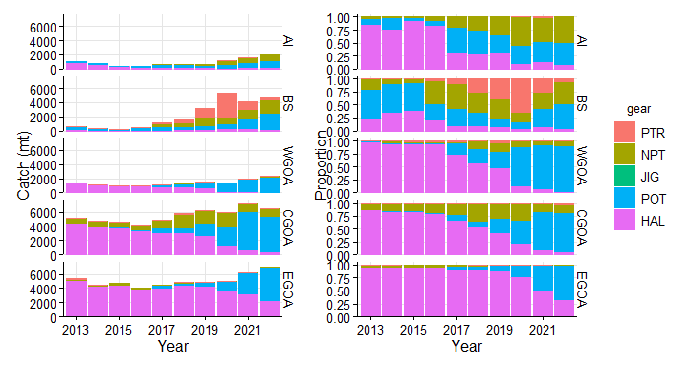

**Figure 2**. Sablefish catch in each observer coverage category in ODDS, including fixed gear electronic monitoring (EM). This catch was not necessarily observed. Gear types include pelagic trawl (PTR), non-pelagic trawl (NPT), Pot (POT), or Hook and Line (HAL). Areas include the Aleutian Islands (AI), Bering Sea (BS), Western Gulf of Alaska (WGOA), Central Gulf of Alaska (CGOA), West Yakutat (WY), and East Yakutat (EY).

* Changes
  + Spell out ODDS

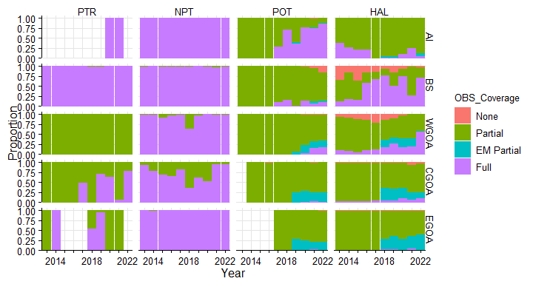

**Figure 3**. Sablefish catch by gear type either observed by electronic monitoring (EM), observers, or no coverage. Biological samples were not taken whenever an observer was present. Gear types include pelagic trawl (PTR), non-pelagic trawl (NPT), Pot (POT), or Hook and Line (HAL). Areas include the Aleutian Islands (AI), Bering Sea (BS), Western Gulf of Alaska (WGOA), Central Gulf of Alaska (CGOA), West Yakutat (WY), and East Yakutat (EY).

* Change
  + Legend should be EM, Observer, No coverage (label above legend is “Coverage”)
  + Add panels with actual catch (not just proportions as below), like in Fig 1

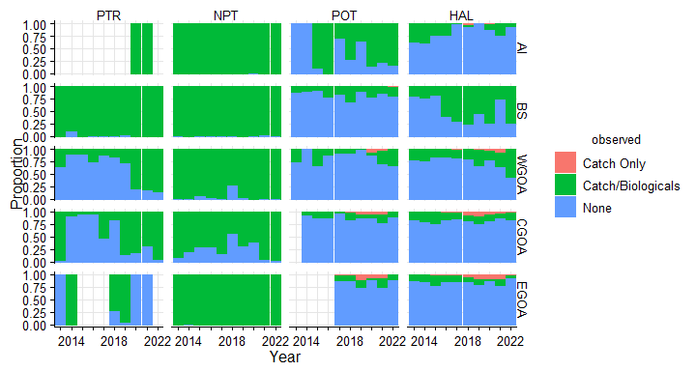

**Figure 4**. The total and proportion of sablefish lengths collected by observers by gear and area. Gear types include pelagic trawl (PTR), non-pelagic trawl (NPT), Pot (POT), or Hook and Line (HAL). Areas include the Aleutian Islands (AI), Bering Sea (BS), Western Gulf of Alaska (WGOA), Central Gulf of Alaska (CGOA), West Yakutat (WY), and East Yakutat (EY).

* Was fig 8 in Cindy report.
* Table

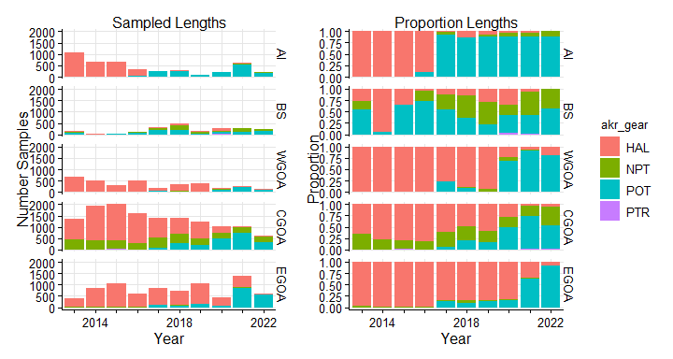

**Figure 5**. The total and proportion of sablefish ages collected by observers by gear and area. Gear types include pelagic trawl (PTR), non-pelagic trawl (NPT), Pot (POT), or Hook and Line (HAL). Areas include the Aleutian Islands (AI), Bering Sea (BS), Western Gulf of Alaska (WGOA), Central Gulf of Alaska (CGOA), West Yakutat (WY), and East Yakutat (EY).

* Same as fig 8, but ages
* Table



**Figure 6**. The number of sablefish lengths collected per ton of catch by management area (panel a) or by gear (panel b). Gear types include pelagic trawl (PTR), non-pelagic trawl (NPT), Pot (POT), or Hook and Line (HAL). Areas include the Aleutian Islands (AI), Bering Sea (BS), Western Gulf of Alaska (WGOA), Central Gulf of Alaska (CGOA), West Yakutat (WY), and East Yakutat (EY).

* Was Fig 9 in Cindy report
* Change
  + Free scale all panels
  + Add one panel for gear (instead of area)
* Table

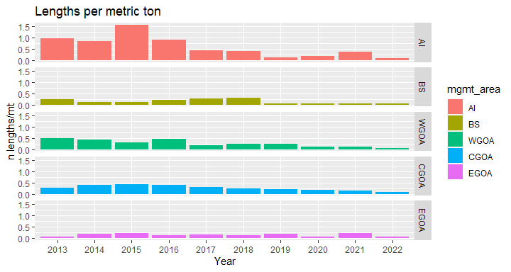

**Figure 7**. The number of sablefish lengths collected per ton of catch by management area and gear. Areas include the Aleutian Islands (AI), Bering Sea (BS), Western Gulf of Alaska (WGOA), Central Gulf of Alaska (CGOA), West Yakutat (WY), and East Yakutat (EY).

* Change
  + NEW – above for reference (len/mt)
  + This would be a lot more panels (6 areas x 4 gears). Will that be legible? Other ideas?

**Figure 8.** The proportion of lengths that were measured at-sea versus in ports by observers.

* Change
  + Base for this was fig 8 in Cindy report
  + Change legend to observer coverage type (port and at-sea).
* Table
  + proportions



**Figure 9.** The proportion of catch with electronic monitoring (EM) review and the number of lengths per mt by area in pot and hook and line gear.

* NEW
* Is EM related to # of samples that are collected? EM up, samples down?
  + How can we look at this?
  + Scatter plots or lines?

**Figure 10. For Cara?** Proportion of fixed gear sablefish catch caught in pots in the GOA, the BSAI, and both combined. This can be line graph in one figure.

* This would naturally go under Fig 1, but if no one else wants it, then maybe I add it to my SAFE and not this report?